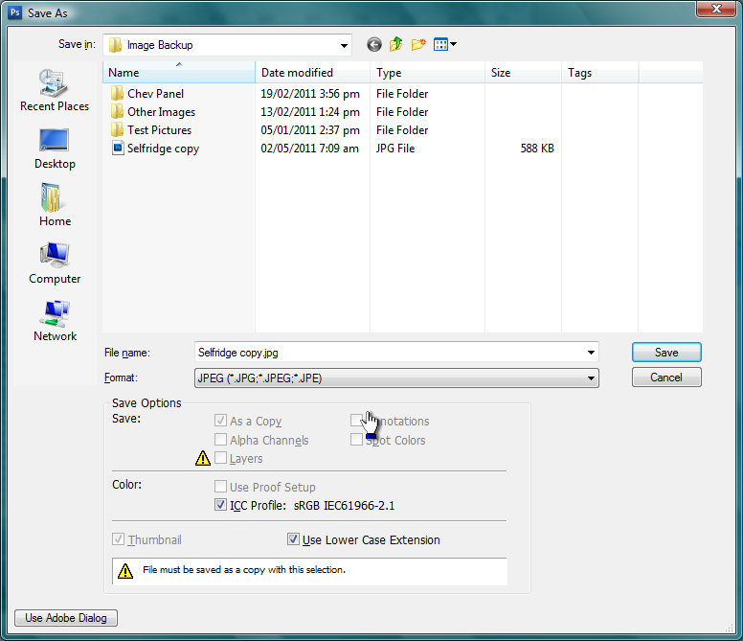
Make sure you have a tick against ICC Profile:, it should read sRGB IEC61966-2.1 if you have sRGB set as your colour space (see colour settings below)

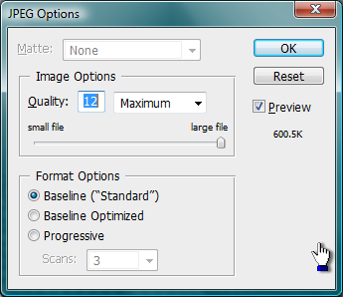
Image options. Set the quality to 12 Maximum.

Format options are only used if saving for display in a web browser. The help system can explain their relevance. Basically Standard is what it says, Optimized creates an enhanced JPEG with a slightly smaller file size. The Optimized JPEG format is recommended for maximum file compression; however, some older browsers do not support this feature. Progressive displays the image progressively in a web browser. The image appears as a series of overlays, in a series of increasly higher resolution steps directed by the number set in Scans:, enabling viewers to see a low-resolution version of the image before it downloads completely.

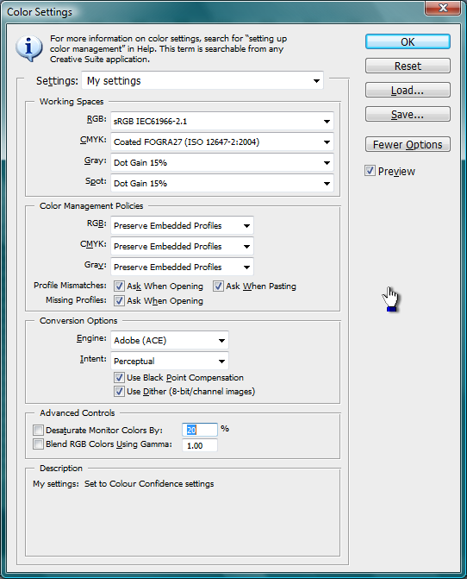

To display working space options in Photoshop, choose Edit> Color Settings.
To view a description of any profile, select the profile and then position the pointer over the profile name. The description appears at the bottom of the dialog box.
RGB
Determines the RGB color space of the application. In general, it’s best to choose Adobe RGB or sRGB, rather than the profile for a specific device (such as a monitor profile).
sRGB is recommended when you prepare images for PDI or the web, because it defines the color space of the standard device used to view the image. sRGB is also a good choice when you work with images from consumer-level digital cameras, because most of these cameras use sRGB as their default color space.
Adobe RGB is recommended when you prepare documents for print, because Adobe RGB’s gamut includes some printable colors (cyans and blues in particular) that can't be defined using sRGB. Adobe RGB is also a good choice when working with images from professional-level digital cameras, because most of these cameras use Adobe RGB as their default color space.
CMYK (used in commercial printing only)
Determines the CMYK color space of the application. All CMYK working spaces are device-dependent, meaning that they are based on actual ink and paper combinations. The CMYK working spaces Adobe supplies are based on standard commercial print conditions.
Gray (Photoshop) or Grayscale (Acrobat)
Determines the grayscale color space of the application.
Spot (Photoshop)
Specifies the dot gain to use when displaying spot color channels and duotones.

